Modern Foreign Languages

Intent:
A high-quality MFL curriculum will encourage all pupils to develop a thirst for exploring and immerging themselves in the wider world around them. Children at Bocking will develop the confidence to express their ideas, thoughts and opinions in different languages without the fear of making mistakes in fluency. All MFL lessons will strive to provide a fun, firm foundation for further language-learning, equipping children with the skills that they need in order to become life-long language learners. By the time the children leave year 6, all pupils will have a greater understanding of the patterns/building blocks of language and will be continually developing the skills to apply their knowledge into their everyday speaking experiences.

Aims
Ensure that each child:
- Teach vocabulary and linguistic structures informed by the National Curriculum and the skills expressed therein: Listening, Speaking, Reading and Writing (as well as Cultural Understanding).
- Has the opportunity to study French as a foreign language, fostering their interest in the culture of France.
- All children to apply their knowledge of phonics in French to spell in a phonetically plausible way and speak with increased confidence.
- Enable children to draw comparisons between French and English vocabulary.
- Enable children to build resilience to make and learn from their mistakes in language.
- To broaden children’s understanding of French as a global language, and the reasons why it is spoken in countries other than France.
- Enable children to understand their place in the wider world and the concept of interdependence.

Implementation:
French is taught on a weekly basis, each lesson 30 minutes in length.
Bocking School will be following the ‘Language Angels’ programme of study. This will ensure that each session is appropriately resourced, planned and accessible to all members of staff teaching the subject.
Lessons are intended to be active, fun and particularly focused on building every child’s confidence to attempt spoken French language. Work is differentiated in a variety of ways to accommodate children in the same class who are all at different stages of their language-learning journeys. Activities consist of games, stories, songs, phonics, grammar and sentence-building activities, rhymes, role-play and dictionary work.
Impact:
Formative and summative assessment are used during French lessons to ensure progress over time. Data gathered is recorded with the help of tracking documentation to demonstrate both attainment and progress over time as well as to identify gaps in knowledge in order to inform the planning of future lessons and units.

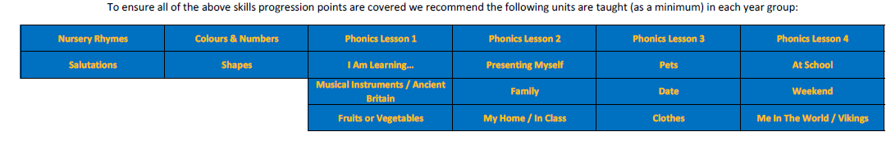
Skills progression by year group
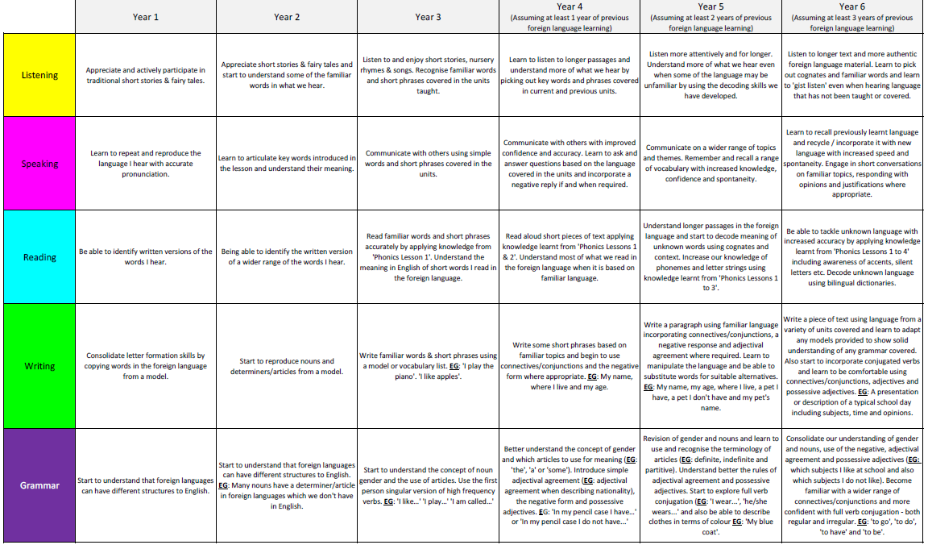
NB: The above progression document is what Bocking School is striving to achieve in the next four years. Currently all year groups in Key Stage 2 are starting from the Year 3 objectives due to limited French learning.

